Pokhara University

Level: Bachelor | Semester – Spring | Year : 2009
Programme: BE |  | Full Marks : 100
 |  | Pass Mark : 45
Course: Control System |  | Time : 3 hrs

Candidates are required to give their answers in their own words as far as practicable.
The figures in the margin indicate full marks.

Attempt all the questions.

1. | - With a suitable example explain the difference between an open loop system and a closed loop system.  - Obtain the mechanical system for the electrical system shown in figure. 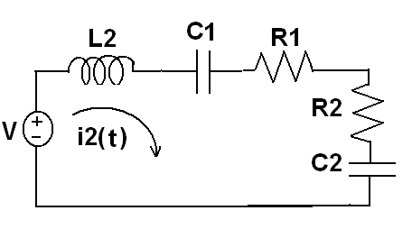 | 7  8
2. | - Obtain the transfer function of the system shown below using Mason’s gain formula.  G₁  G₂  G₃  G₄  G₅  G₆  G₇  G₈  G₉  G₁₀  G₁₁  - The transfer function of the system is given by  Y(s)/U(s) = ( s+3)/ {(s +1)(s+2)}  Obtain the state model using either cascade or parallel decomposition. | 7  8
3. | - A closed loop system is shown in below  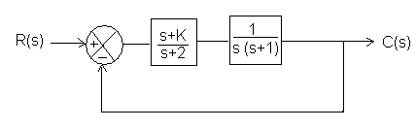  Using Routh Criteria calculate the values of K for which the system is stable.  - When the system shown in figure (a) below is subjected to a unit step input, the system output responds as shown in figure (b). Determine the values of K and T from the response curve.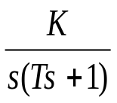  R(s)  C(s)  +  -  Figure (a)  Figure (b)  c(t)  t  1.254  1  3 | 7  8
4. | Sketch the root locus for 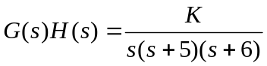 and evaluate the value of K at the point where the root loci crosses the imaginary axis. Also determine the value of K so that the dominant pair of complex poles of the system has a damping ratio of 0.5. | 15
5. | - Sketch the Bode plot for the open loop transfer function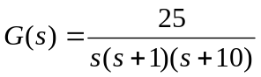. Determine the gain margin, phase margin and the system stability.  - Sketch the polar plot of the system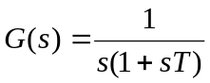. | 9  6
6. | Design a suitable lead compensating network for a system with open loop transfer function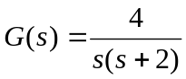, with velocity error constant Kv = 20 sec⁻¹, phase margin at least 50° and gain margin is at least 10 dB. | 15
7. | Write short notes on (Any Two):  - Analogous System  - Effect of feedback on stability  - Time domain specifications | 2×5

